MAT 3749 2.2 Part I Handout
Continuous at a Point
A function defined on an open interval contains is continuous at c if

The e-d Definition
A function defined on an open interval contains is continuous at c if
, such that whenever .

Example 1
Use the definition to prove that is continuous at 2.

Analysis

Continuous on an Open Interval
A function is continuous on an open interval if it is continuous at every number of the interval.

Example 2
Use the definition to prove that is continuous on.

Analysis

Continuous from the Left
A function defined on an interval is continuous from the left at c if

Continuous on an Interval
A function is continuous on an interval if it is continuous at every number of the interval. (We understand continuous at the end points to mean continuous from the left/right.)

Common Continuous Functions
Polynomials, Power Functions, Rational Functions, Root Functions, Trigonometric Functions are continuous at every number in their domains.

Combinations of Continuous Functions
If f and g are continuous at a, then, , , , are also continuous at where is a constant and .

Theorem
If is continuous at and is continuous at , then the composite function is continuous at .

Analysis

Proof

Let and .
Let .
is continuous at such that if then .
For ,
is continuous at such that if then
So, is continuous at a.

The Intermediate Value Theorem
Suppose that f is continuous on the closed interval and let N be any number between and , where . Then there exists a number c in such that .

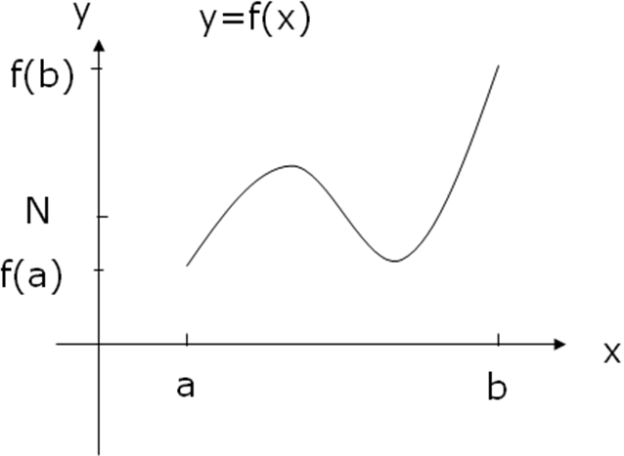

Applications
Suppose that f is continuous on the closed interval and that , are with different signs. Then there exists a number c in such that .

Analysis

Proof

Example 3
Show that there is a root of the equation
between 1 and 2.

Analysis

Solution

